Date :14/02/2023 Seat No:

…………………………………………………......

**PRACTICAL NO.5**

**Aim:** **Working with Projections and WMS Data**

**Step 1:- Start a new Project.**

**Step 2:- Go to Layer → Add Layer →Vector Layer.**

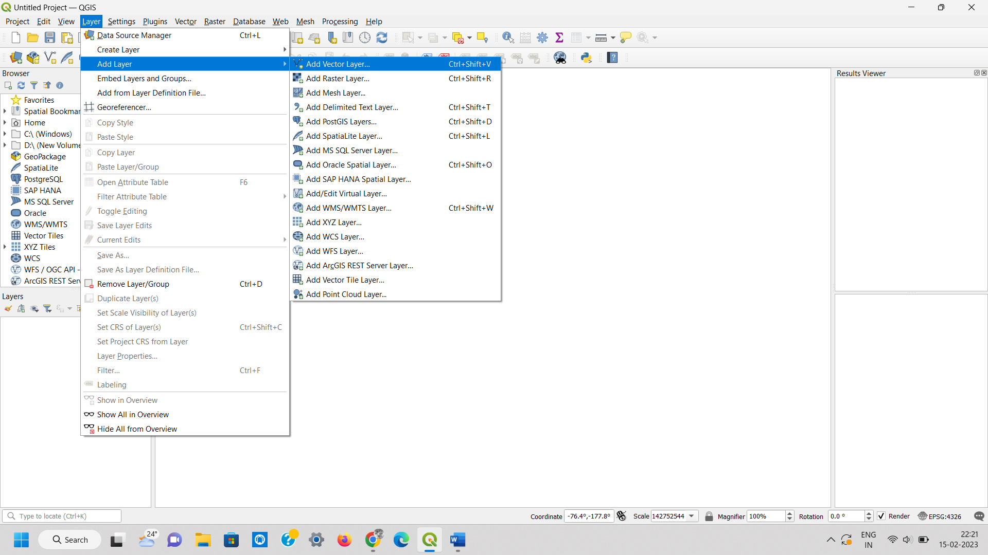

**Step 3:- Select “ne_10m_admin_0_countries.zip” Layer from data folder.**

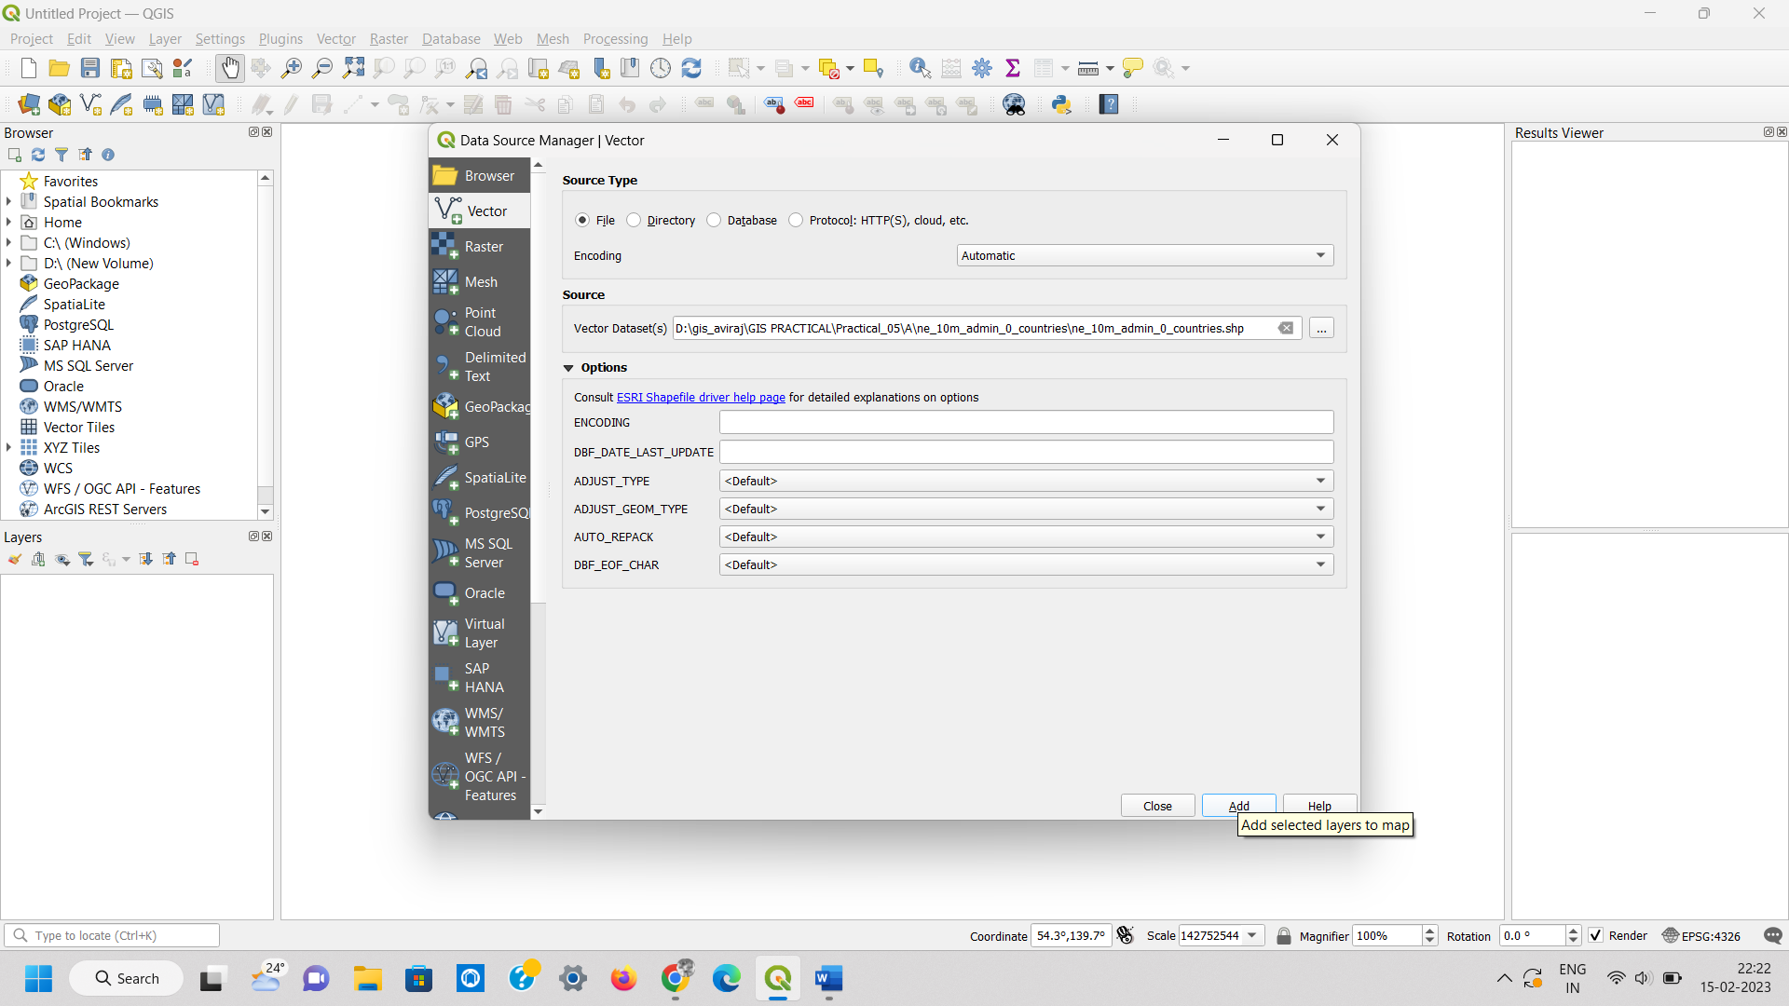

**Step 4:- Go to Layer → Save As.**

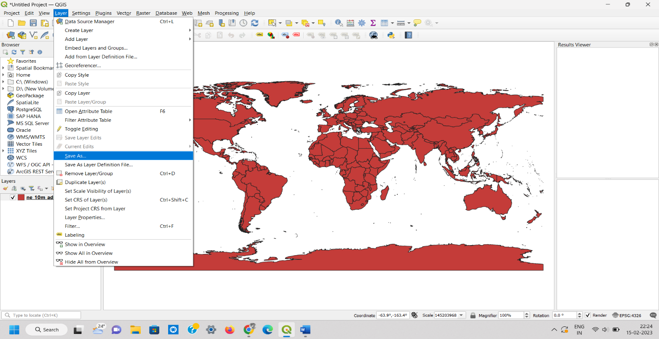

**Step 5:- Select format as ESRI Shape File. And also Select folder location and file name And Set CRS North_America_Albers_Equal_Area_Conic EPSG: 102008.**

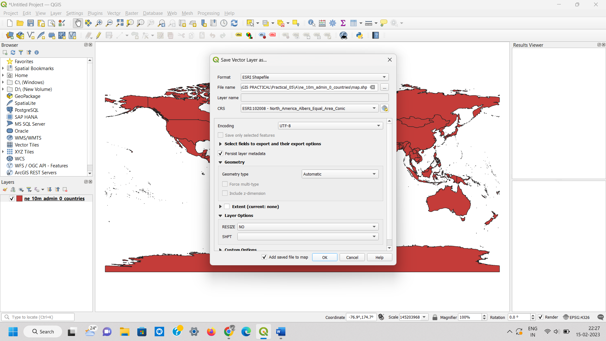

**Step 6:- Press “OK”.**

**Deselect the original Image and keep the projected layer visible.**

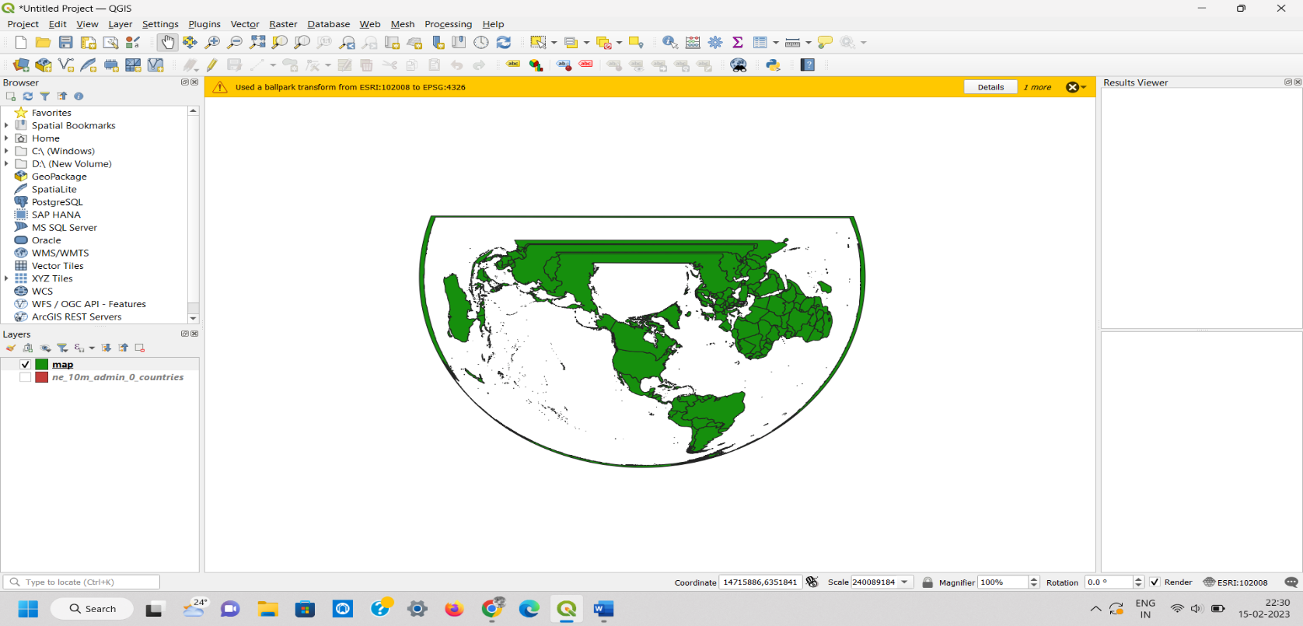

**Step 7:- Select Layer → Add Layer → Add Raster Layer → Select MiniScale_(standard)_R17.tif from Location.**

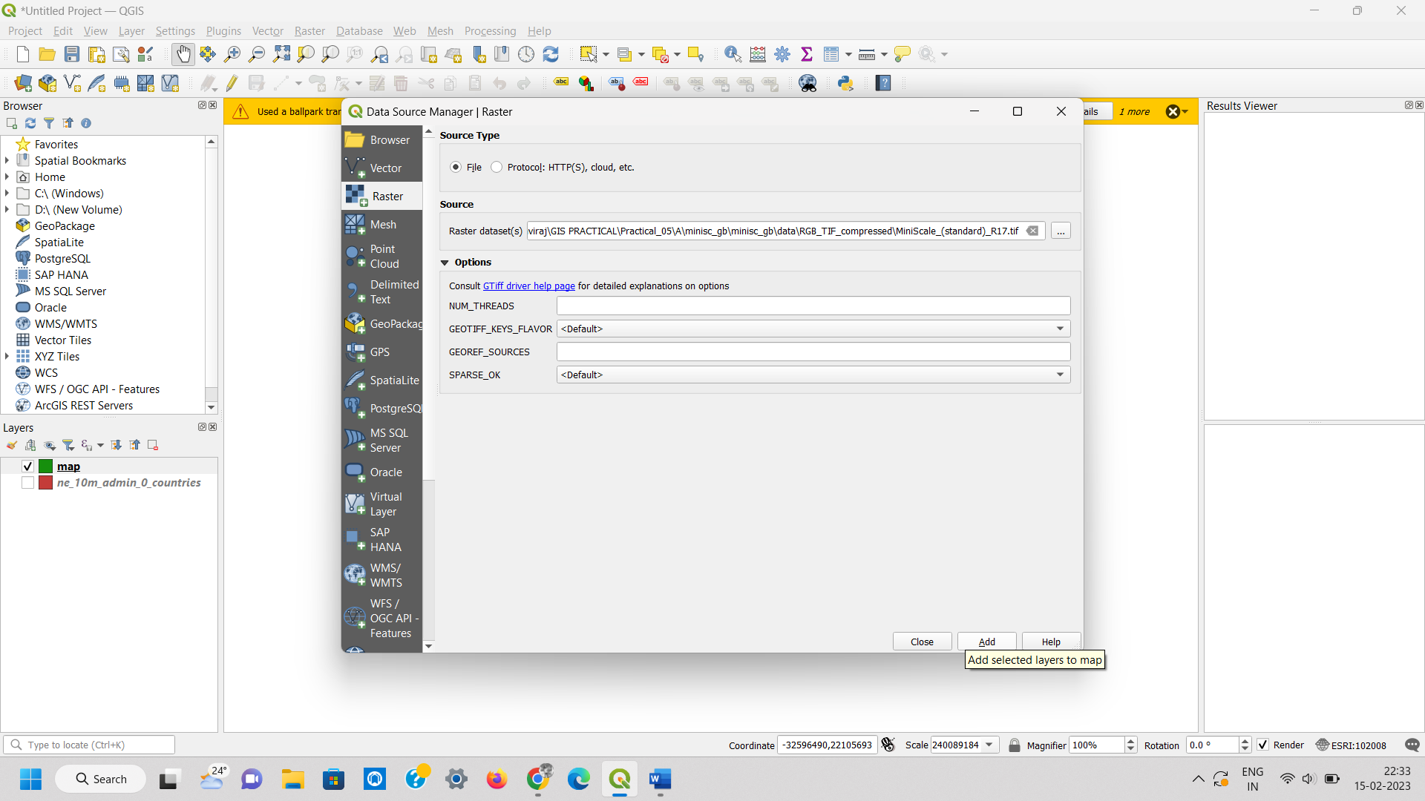

**Step 8:- Open Project Properties→CRS → Search bri → select British National Grid EPSG 27700.**

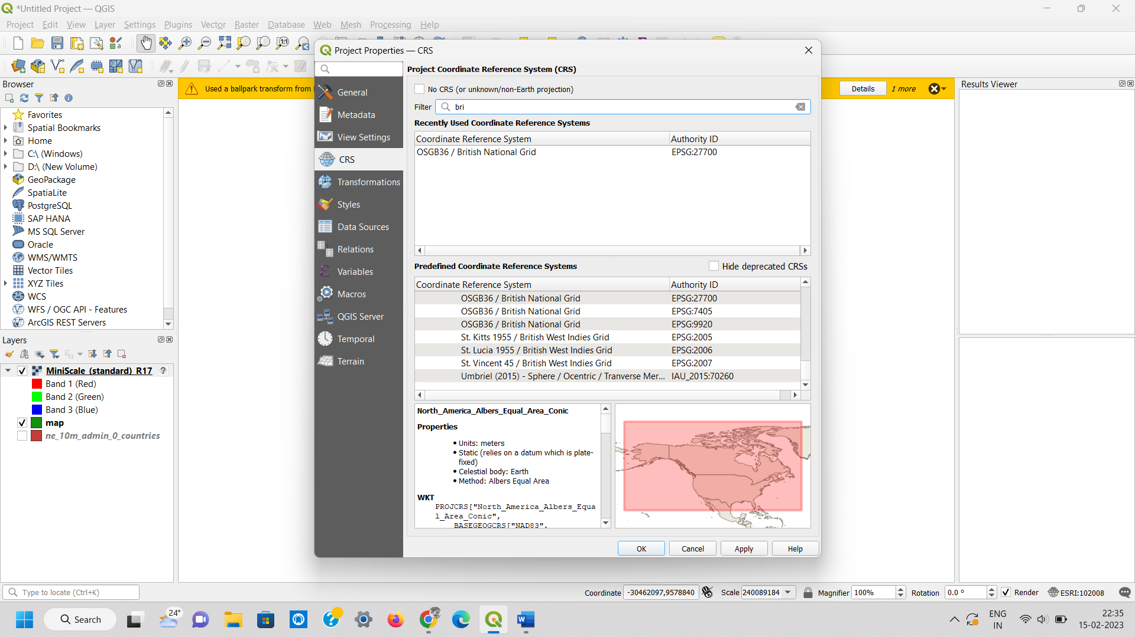

**Output:-**

